Name: ________________________________ Class: ___________ Score: ________

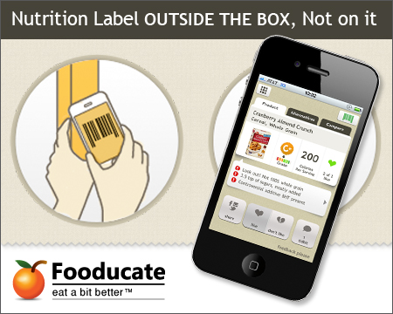
Fooducate It!

How Fooducate Grades Products:
All products are graded from A down to D based on product's nutrition facts panel and ingredient list. Minimally processed, real foods with intrinsic nutrients will score better than processed foods that are poor in built-in nutrients.There are 10 distinct grades: A, A-, B+, B, B-, C+, C, C-, D+, and D.
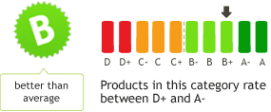

Directions:
- Step One: Guessing…
  - Place all food products face up on your desk and WITHOUT reading and/or evaluating the nutrition facts try to “Grade” all food products placing them into four piles:
    - Pile A: Excellent and healthy food choice
    - Pile B: Good food choice
    - Pile C: Fair food choice
    - Pile D: Unhealthy food choice
  - Complete the chart below:
Top 3 healthiest food choices: | Give evidence to support why you think this food choice is healthy.

- Step Two: Reading…
  - Read the ingredients list and nutrition facts for each food product and if necessary, adjust you’re the foods in your piles according to their nutritional density. Example: If you thought a food product as an A, but after you read the Nutrition Facts, you think the food product is now a C, move that food item to the C pile.
  - Complete the chart below:
Top 3 healthiest food choices: | Give evidence to support why this food choice is healthy.

- Step Three: Fooducating…
  - Using the Fooducate app. on your phone, “Fooducate” each item in your pile making adjustments to your pile(s) when necessary. Example: If you thought a food item as an B, but it is “fooducated” to be a D, move that food item to the D pile.
  - Complete the chart below:
Top 3 healthiest food choices: | What nutrition grade did this product get? | What evidence did Fooducate give to confirm this food product is a healthy choice?

- What did you learn about food products and nutrition choices as you proceeded through the three steps in this activity?

__________________________________________________________________________________________

- How might “Fooducate” be helpful concerning choices YOU make about the foods you eat?

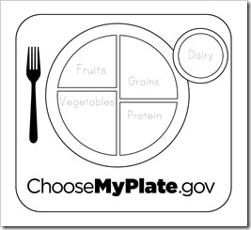
__________________________________________________________________________________________
6. Using all the food products at your table, select five that are nutrient dense (healthy choices) and write the names of those food products where they would belong on the MyPlate chart to the right.

7. Under the food product(s) you selected to write on MyPlate, write the portion size that would be considered one serving.

Example:
In the grain group you would write:
Cereal: Honey Nut Cheerios
¾ cups = 1 serving

dlt2015

